CAS SciFinder Task History

January 2, 2025, 5:15 PM

Initiating Search

Reactions: | Structure Search  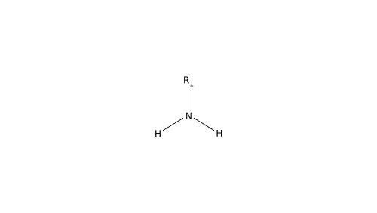  R-Groups  R1: X, A

Filtered By:
Structure Match: As Drawn
Substance Role: Reactant
Yield: 90-100%
Non-Participating Functional Groups: Halide, Alkene, Ether, Cyclic alkene, Phenyl halide, Imine, Amine, Amide, Nitro, Carboxamidine, Carboxylic ester, Carbamate, Tertiary amine, Alcohol, Alkyl halide, Diene, Acyclic alkene, Ketone, Secondary amine, Cyclic alcohol, Sulfide, Acetal, Secondary alcohol, Cyclic ketone, Oxime, Nitrile, Phenol, Primary amine, Unsaturated ketone, Acyclic ketone, Unsaturated ester, Carboxylic acid, Primary alcohol, Urea, Thiocarbonyl, Alkyne, Organometal, Tertiary alcohol, Azide, Cyclic ester, Glycol, Sulfone, Cyclopentadienyl metal, Vinyl halide, Allyl alcohol, Phosphonate, Aldehyde, Enol, Epoxide, Sulfoxide, Metal halide, Isonitrile, Anhydride, Carbonic ester, Hemiacetal, Thiol, Unsaturated aldehyde, Acid halide, Diazo, Disulfide, Hydroxylamine, Isocyanate, Sulfonyl halide, Thiocarboxy
Reaction Mapping: Mapping Data Available
Reaction Type: Full
Language: English
Publication Year: 2000 to 2024

Excluded:
Substance Role: Reagent
Catalyst: L-Proline, Citric acid, 1-Propanesulfonic acid, 2485069-11-0, 2826191-69-7, 2826191-71-1, Peptide C-terminal amidase
Reaction Notes: Enzymic, High Pressure, Low Pressure, Microwave Irradiation, Thermal, Gas Phase

Search Tasks

1. Exported: Returned Reaction Results + Filters (5,084) View Results

View in CAS SciFinder

Reactions (84)

1. Scheme 1 (1 Reaction)

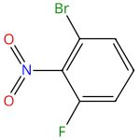 |  | 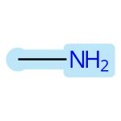 |  | 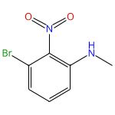

Fragment Based Optimization of Metabotropic Glutamate Receptor 2 (mGluR2) Positive Allosteric Modulators in the Absence of Structural Information
By: Szabo, Gyorgy; et al
Journal of Medicinal Chemistry (2019), 62(1), 234-246.
Find It @ Emory
10.1021/acs.jmedchem.8b00161
View All Sources in CAS SciFinder

Steps: 1, Yield: 90%
CAS Reaction Number: 31-172-CAS-19493123
1.1 | Reagents: Potassium carbonate
 | Solvents: Acetonitrile; 18 h, rt

2. Scheme 2 (1 Reaction)

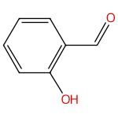 |  |  |  | 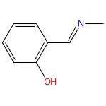

Synthesis, spectra, redox properties and catalytic activity of ruthenium(III) Schiff base complexes
By: Venkatachalam, G.; et al
Indian Journal of Chemistry, Section A: Inorganic, Bio-inorganic, Physical, Theoretical & Analytical Chemistry (2005), 44A(4), 705-709.
Find It @ Emory
View All Sources in CAS SciFinder

Steps: 1, Yield: 90%
CAS Reaction Number: 31-309-CAS-6201545
1.1 | Solvents: Methanol; 1 h, reflux

3. Scheme 3 (1 Reaction)

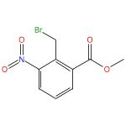 |  |  |  | 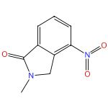

Discovery of a Bromodomain and Extra Terminal Domain (BET) Inhibitor with the Selectivity for the Second Bromodomain (BD2) and the Capacity for the Treatment of Inflammatory Diseases
By: Wang, Zhijie; et al
Journal of Medicinal Chemistry (2023), 66(15), 10824-10848.
Find It @ Emory
10.1021/acs.jmedchem.3c01028
View All Sources in CAS SciFinder

Steps: 1, Yield: 90%
CAS Reaction Number: 31-614-CAS-37362864
1.1 | Solvents: Tetrahydrofuran, Water; rt; 5 h, rt

4. Scheme 4 (3 Reactions)

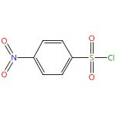 |  |  |  | 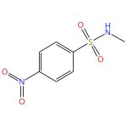

Studies on the Synthesis of the Alkaloid (-)-Gilbertine via Indolidene Chemistry
By: Feldman, Ken S.; et al
Journal of Organic Chemistry (2016), 81(11), 4566-4575.
Find It @ Emory
10.1021/acs.joc.6b00348
View All Sources in CAS SciFinder

Steps: 1, Yield: 90%
CAS Reaction Number: 31-393-CAS-15592369
1.1 | Solvents: Dichloromethane, Water; 0 °C

Compounds inducing chondrogenesis and their preparation
Assignees: The Scripps Research Institute; The California Institute for Biomedical Research
United States, US20140271955 A1 2014-09-18
Espacenet
View All Sources in CAS SciFinder

Steps: 1, Yield: 90%
CAS Reaction Number: 31-393-CAS-14162638
1.1 | Solvents: Dichloromethane; 2 h, rt

Preparation of hydrazonodiaminopyrazoles with antiproliferative activity.
Assignee: Unknown
United States, US20030060453 A1 2003-03-27
Espacenet
View All Sources in CAS SciFinder

Steps: 1, Yield: 90%
CAS Reaction Number: 31-393-CAS-2418029
1.1 | Reagents: Triethylamine
 | Solvents: Tetrahydrofuran; rt
1.2 | Solvents: Tetrahydrofuran; 0 °C; overnight, rt

5. Scheme 5 (1 Reaction)

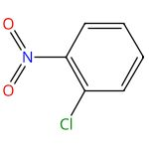 |  |  |  | 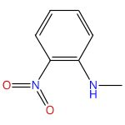

An improved synthesis of N-substituted-2-nitroanilines
By: Chauhan, S. M. S.; et al
Synthetic Communications (2003), 33(16), 2899-2906.
Find It @ Emory
10.1081/scc-120022180
View All Sources in CAS SciFinder

Steps: 1, Yield: 90%
CAS Reaction Number: 31-172-CAS-14962171
1.1 | Reagents: 1,8-Diazabicyclo[5.4.0]undec-7-ene; 1 h, 80 °C

6. Scheme 6 (1 Reaction)

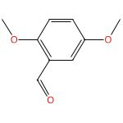 |  |  |  | 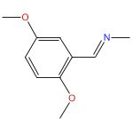

Cholinesterase inhibitors: SAR and enzyme inhibitory activity of 3-[ω-(benzylmethylamino)alkoxy]xanthen-9-ones
By: Piazzi, Lorna; et al
Bioorganic & Medicinal Chemistry (2007), 15(1), 575-585.
Find It @ Emory
10.1016/j.bmc.2006.09.026
View All Sources in CAS SciFinder

Steps: 1, Yield: 90%
CAS Reaction Number: 31-309-CAS-4900269
1.1 | Solvents: Ethanol, Water; 40 °C; 2 h, 0 - 5 °C

7. Scheme 7 (4 Reactions)

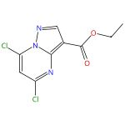 |  |  |  | 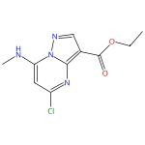

Substituted 7-(methylamino)pyrazolo[1,5-a]pyrimidine-3-carboxamide derivatives
Assignee: Eli Lilly and Company
World Intellectual Property Organization, WO2021162944 A1 2021-08-19
Espacenet
View All Sources in CAS SciFinder

Steps: 1, Yield: 90%
CAS Reaction Number: 31-614-CAS-24222206
1.1 | Solvents: Ethanol, Tetrahydrofuran; < 20 °C; 20 °C → 22 °C; 4 h, 22 °C
1.2 | Reagents: Water; 1 h, 22 °C

7-(Methylamino)pyrazolo[1,5-a]pyrimidine-3-carboxamide compounds as TYK2-JH2 inhibitors and their preparation
Assignee: Eli Lilly and Company
World Intellectual Property Organization, WO2021162942 A1 2021-08-19
Espacenet
View All Sources in CAS SciFinder

Steps: 1, Yield: 90%
CAS Reaction Number: 31-614-CAS-24308378
1.1 | Solvents: Ethanol, Tetrahydrofuran; < 20 °C; 20 °C → 22 °C; 4 h, 22 °C

Preparation of 7-(methylamino)pyrazolo[1,5-a]pyrimidine-3-carboxamide derivatives for treating psoriasis or systemic lupus erythematosus
Assignee: Eli Lilly and Company
World Intellectual Property Organization, WO2020123225 A1 2020-06-18
Espacenet
View All Sources in CAS SciFinder

Steps: 1, Yield: 90%
CAS Reaction Number: 31-172-CAS-22657282
1.1 | Solvents: Ethanol, Tetrahydrofuran; < 20 °C; 4 h, 22 °C
1.2 | Solvents: Water; 1 h

Preparation of pyrazolo[1,5-a]pyrimidine-3-carboxamide derivatives useful in the treatment of psoriasis and systemic lupus erythematosus
Assignee: Eli Lilly and Company
World Intellectual Property Organization, WO2020055636 A1 2020-03-19
Espacenet
View All Sources in CAS SciFinder

Steps: 1, Yield: 90%
CAS Reaction Number: 31-172-CAS-21732949
1.1 | Solvents: Ethanol, Tetrahydrofuran; < 20 °C; 20 °C → 22 °C; 4 h, 22 °C

8. Scheme 8 (1 Reaction)

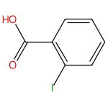 |  |  |  | 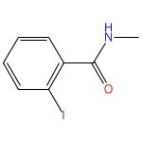

Diversity-oriented enantioselective construction of atropisomeric heterobiaryls and N-aryl indoles via vinylidene ortho-quinone methides
By: Xu, Da; et al
CCS Chemistry (2022), 4(8), 2686-2697.
Find It @ Emory
10.31635/ccschem.021.202101154
View All Sources in CAS SciFinder

Steps: 1, Yield: 90%
CAS Reaction Number: 31-614-CAS-34300374
1.1 | Reagents: Oxalyl chloride
 | Catalysts: Dimethylformamide
 | Solvents: Dichloromethane; rt
1.2 | Reagents: Triethylamine
 | Solvents: Dichloromethane; 6 h, rt
1.3 | Reagents: Water; rt

9. Scheme 9 (1 Reaction)

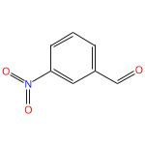 |  |  |  | 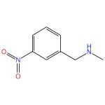

Installation of Pargyline, a LSD1 Inhibitor, in the HDAC Inhibitory Template Culminated in the Identification of a Tractable Antiprostate Cancer Agent
By: Ojha, Ritu; et al
Journal of Medicinal Chemistry (2021), 64(24), 17824-17845.
Find It @ Emory
10.1021/acs.jmedchem.1c00966
View All Sources in CAS SciFinder

Steps: 1, Yield: 90%
CAS Reaction Number: 31-614-CAS-39627296
1.1 | Solvents: Water; 12 h, rt
1.2 | Reagents: Sodium borohydride; 0 °C; 5 h, rt
1.3 | Reagents: Water; rt

10. Scheme 10 (1 Reaction)

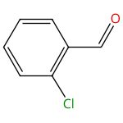 |  |  |  | 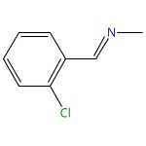

Cholinesterase inhibitors: SAR and enzyme inhibitory activity of 3-[ω-(benzylmethylamino)alkoxy]xanthen-9-ones
By: Piazzi, Lorna; et al
Bioorganic & Medicinal Chemistry (2007), 15(1), 575-585.
Find It @ Emory
10.1016/j.bmc.2006.09.026
View All Sources in CAS SciFinder

Steps: 1, Yield: 90%
CAS Reaction Number: 31-309-CAS-7637404
1.1 | Solvents: Ethanol, Water; 40 °C; 2 h, 0 - 5 °C

11. Scheme 11 (1 Reaction)

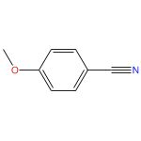 |  |  |  | 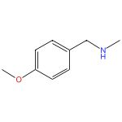

Nickel-catalyzed hydrogenative coupling of nitriles and amines for general amine synthesis
By: Chandrashekhar, Vishwas G.; et al
Science (Washington, DC, United States) (2022), 376(6600), 1433-1441.
Find It @ Emory
10.1126/science.abn7565
View All Sources in CAS SciFinder

Steps: 1, Yield: 90%
CAS Reaction Number: 31-614-CAS-32794894
1.1 | Reagents: Hydrogen
 | Catalysts: 1,1′-[2-[(Diphenylphosphino)methyl]-2-methyl-1,3-propanediyl]bis[1,1-diphenylphosphine], Methanesulfonic acid, 1,1,1-trifluoro-, nickel(2+) salt (2:1)
 | Solvents: 2,2,2-Trifluoroethanol; 16 h, 40 bar, 100 °C

12. Scheme 12 (1 Reaction)

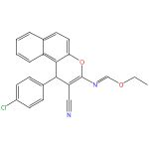 |  |  |  | 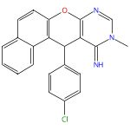

Synthesis and antibacterial activity of some new benzo[5,6]chromeno[2,3-d]pyrimidines
By: Ameli, Shohreh; et al
Russian Journal of Bioorganic Chemistry (2017), 43(4), 429-434.
Find It @ Emory
10.1134/s1068162017040100
View All Sources in CAS SciFinder

Steps: 1, Yield: 90%
CAS Reaction Number: 31-032-CAS-22119678
1.1 | Solvents: Methanol; 10 - 20 min, reflux

13. Scheme 13 (1 Reaction)

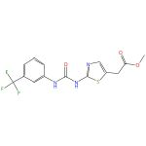 |  |  |  | 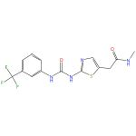

Thienopyrimidines useful as Aurora kinase inhibitors and their preparation, pharmaceutical compositions, and their use for treatment of Aurora kinase-mediated diseases
Assignee: Sunesis Pharmaceuticals, Inc.
United States, US20060035908 A1 2006-02-16
Espacenet
View All Sources in CAS SciFinder

Steps: 1, Yield: 90%
CAS Reaction Number: 31-368-CAS-15005040
1.1 | Reagents: Magnesium chloride
 | Solvents: Tetrahydrofuran; > 1 h, rt

14. Scheme 14 (1 Reaction)

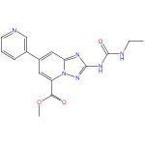 |  |  |  | 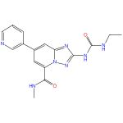

DNA gyrase (GyrB)/topoisomerase IV (ParE) inhibitors: Synthesis and antibacterial activity
By: East, Stephen P.; et al
Bioorganic & Medicinal Chemistry Letters (2009), 19(3), 894-899.
Find It @ Emory
10.1016/j.bmcl.2008.11.102
View All Sources in CAS SciFinder

Steps: 1, Yield: 90%
CAS Reaction Number: 31-368-CAS-12073736
1.1 | Reagents: Trimethylaluminum
 | Solvents: Toluene, 1,4-Dioxane; 45 °C

15. Scheme 15 (1 Reaction)

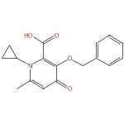 |  |  |  | 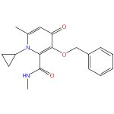

Process for the preparation of 3-hydroxy-1-cycloalkyl-6-alkyl-4-oxo-1,4-dihydropyridine-2-carboxamides by treatment of the corresponding acids with acid chloride formation reagents and amines.
Assignee: Apotex Inc.
Canada, CA2488034 A1 2006-05-19
Espacenet
View All Sources in CAS SciFinder

Steps: 1, Yield: 90%
CAS Reaction Number: 31-367-CAS-4667862
1.1 | Reagents: Oxalyl chloride
 | Solvents: Dimethylformamide, Dichloromethane; 1 h, 4 °C; 15 min, < 10 °C
1.2 | Reagents: Triethylamine
 | Solvents: Dichloromethane, Tetrahydrofuran; 2.5 h, 4 °C; 10 min, < 8 °C
1.3 | Reagents: Sodium chloride
 | Solvents: Water; 5 min

16. Scheme 16 (1 Reaction)

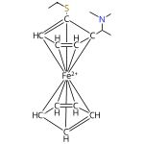 |  |  |  | 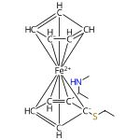

Easily accessible ferrocenyl N-P/S type ligands and their applications in asymmetric allylic substitutions
By: Lam, Fuk Loi; et al
Tetrahedron: Asymmetry (2006), 17(4), 497-499.
Find It @ Emory
10.1016/j.tetasy.2005.12.037
View All Sources in CAS SciFinder

Steps: 1, Yield: 90%
CAS Reaction Number: 31-614-CAS-28976335
1.1 | Reagents: Acetic anhydride

17. Scheme 17 (1 Reaction)

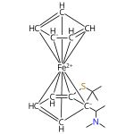 |  |  |  | 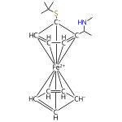

Easily accessible ferrocenyl N-P/S type ligands and their applications in asymmetric allylic substitutions
By: Lam, Fuk Loi; et al
Tetrahedron: Asymmetry (2006), 17(4), 497-499.
Find It @ Emory
10.1016/j.tetasy.2005.12.037
View All Sources in CAS SciFinder

Steps: 1, Yield: 90%
CAS Reaction Number: 31-614-CAS-29776441
1.1 | Reagents: Acetic anhydride

18. Scheme 18 (1 Reaction)

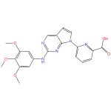 |  |  |  | 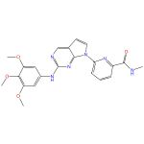

Design and synthesis of 7H-pyrrolo[2,3-d]pyrimidines as focal adhesion kinase inhibitors. Part 2
By: Choi, Ha-Soon; et al
Bioorganic & Medicinal Chemistry Letters (2006), 16(10), 2689-2692.
Find It @ Emory
10.1016/j.bmcl.2006.02.032
View All Sources in CAS SciFinder

Steps: 1, Yield: 90%
CAS Reaction Number: 31-367-CAS-2817413
1.1 | Reagents: Oxalyl chloride
 | Catalysts: Dimethylformamide
 | Solvents: Dichloromethane; 3 h, 25 °C
1.2 | 2 h, 25 °C

19. Scheme 19 (2 Reactions)

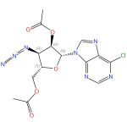  Absolute stereochemistry shown |  |  |  | 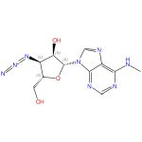  Absolute stereochemistry shown

Synthesis of N6-Substituted 3’-Ureidoadenosine Derivatives as Highly Potent Agonists at the Mutant A3 Adenosine Receptor
By: Jeong, Lak Shin; et al
Nucleosides, Nucleotides & Nucleic Acids (2007), 26(6-7), 717-719.
Find It @ Emory
10.1080/15257770701493161
View All Sources in CAS SciFinder

Steps: 1, Yield: 90%
CAS Reaction Number: 31-172-CAS-1556671
1.1 | Solvents: 1,4-Dioxane; rt
1.2 | Reagents: Sodium methoxide
 | Solvents: Methanol; rt

Orthogonal Activation of the Reengineered A3 Adenosine Receptor (Neoceptor) Using Tailored Nucleoside Agonists
By: Gao, Zhan-Guo; et al
Journal of Medicinal Chemistry (2006), 49(9), 2689-2702.
Find It @ Emory
10.1021/jm050968b
View All Sources in CAS SciFinder

Steps: 1, Yield: 90%
CAS Reaction Number: 31-172-CAS-3043118
1.1 | Solvents: 1,4-Dioxane, Water; 4 h, rt

20. Scheme 20 (1 Reaction)

 |  | 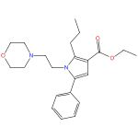 |  | 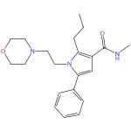

Solution Phase Synthesis of a Library of Tetrasubstituted Pyrrole Amides
By: Bianchi, Ivana; et al
Journal of Combinatorial Chemistry (2006), 8(4), 491-499.
Find It @ Emory
10.1021/cc060008q
View All Sources in CAS SciFinder

Steps: 1, Yield: 90%
CAS Reaction Number: 31-368-CAS-1740139
1.1 | Reagents: Trimethylaluminum
 | Solvents: Toluene, Hexane; 15 min, rt
1.2 | Solvents: Toluene; overnight, 90 °C

21. Scheme 21 (3 Reactions)

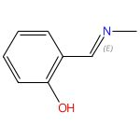

Double bond geometry shown

(Phenoxyimine)nickel-Catalyzed C(sp2)-C(sp3) Suzuki-Miyaura Cross-Coupling: Evidence for a Recovering Radical Chain Mechanism
By: Mills, L. Reginald; et al
Journal of the American Chemical Society (2024), 146(14), 10124-10141.
Find It @ Emory
10.1021/jacs.4c01474
View All Sources in CAS SciFinder

Steps: 1, Yield: 90%
CAS Reaction Number: 31-614-CAS-41078227
1.1 | Solvents: Methanol, Tetrahydrofuran; 16 h, 0 °C

Phenoxythiazoline (FTz)-Cobalt(II) Precatalysts Enable C(sp2)-C(sp3) Bond-Formation for Key Intermediates in the Synthesis of Toll-like Receptor 7/8 Antagonists**
By: Mills, L. Reginald; et al
Angewandte Chemie, International Edition (2023), 62(51), e202313848.
Find It @ Emory
10.1002/anie.202313848
View All Sources in CAS SciFinder

Steps: 1, Yield: 90%
CAS Reaction Number: 31-614-CAS-39551172
1.1 | Solvents: Methanol, Tetrahydrofuran; 16 h, 0 °C

Phenoxythiazoline (FTz)-Cobalt(II) precatalysts enable C(sp2)-C(sp3) bond-formation for the key intermediate in the synthesis of afimetoran and related toll-like receptor 7/8 (TLR7/8) antagonists
By: Mills, L. Reginald; et al
ChemRxiv (2023), 1-21.
Find It @ Emory
10.26434/chemrxiv-2023-7631n
View All Sources in CAS SciFinder

Steps: 1, Yield: 90%
CAS Reaction Number: 31-614-CAS-37881712
1.1 | Solvents: Methanol, Tetrahydrofuran; 16 h, 0 °C; 0 °C → rt

22. Scheme 22 (1 Reaction)

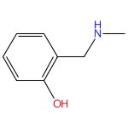

Synthesis of 3,4-Dihydro-2H-1,3-benzoxazines by Condensation of 2-Hydroxyaldehydes and Primary Amines: Application to the Synthesis of Hydroxy-Substituted and Deuterium-Labeled Compounds
By: Andreu, R.; et al
Synthetic Communications (2008), 38(14), 2316-2329.
Find It @ Emory
10.1080/00397910802138629
View All Sources in CAS SciFinder

Steps: 1, Yield: 90%
CAS Reaction Number: 31-313-CAS-5331039
1.1 | Solvents: Ethanol; 4 h, 60 °C; 60 °C → rt
1.2 | Reagents: Sodium borohydride; rt

23. Scheme 23 (1 Reaction)

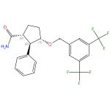  Relative stereochemistry shown |  |  |  | 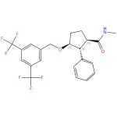  Relative stereochemistry shown

Cyclopentane-based human NK1 antagonists. Part 1: discovery and initial SAR
By: Finke, Paul E.; et al
Bioorganic & Medicinal Chemistry Letters (2006), 16(17), 4497-4503.
Find It @ Emory
10.1016/j.bmcl.2006.06.035
View All Sources in CAS SciFinder

Steps: 1, Yield: 90%
CAS Reaction Number: 31-041-CAS-11655069
1.1 | Reagents: Oxalyl chloride
 | Catalysts: Dimethylformamide
 | Solvents: Dichloromethane
1.2 | Solvents: Tetrahydrofuran, Water

24. Scheme 24 (1 Reaction)

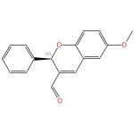  Absolute stereochemistry shown,  Rotation (+) |  |  |  | 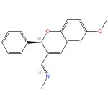  Absolute stereochemistry shown,  Rotation (+)  Double bond geometry shown

Multifaceted Domino Knoevenagel-Cyclization Reactions; Four Movements for 2H-Chromenes and Chromans
By: Balazs Kiraly, Sandor; et al
Advanced Synthesis & Catalysis (2023), 365(19), 3301-3319.
Find It @ Emory
10.1002/adsc.202300083
View All Sources in CAS SciFinder

Steps: 1, Yield: 90%
CAS Reaction Number: 31-614-CAS-36124655
1.1 | Solvents: Ethanol; 2 h, reflux

25. Scheme 25 (1 Reaction)

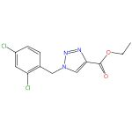 |  |  |  | 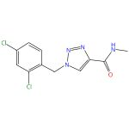

Synthesis and anticonvulsant activity of 1-substituted benzyl N-substituted 1,2,3-triazole-4-carboxanilides
By: Wang, Junmin; et al
Progress in Natural Science (2006), 16(9), 925-929.
Find It @ Emory
View All Sources in CAS SciFinder

Steps: 1, Yield: 90%
CAS Reaction Number: 31-368-CAS-9885711
1.1 | Solvents: Propylamine; rt

26. Scheme 26 (1 Reaction)

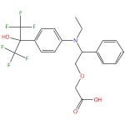 |  |  |  | 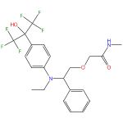

Synthesis and evaluation of anilinohexafluoroisopropanols as activators/modulators of LXRα and β
By: Panday, Narendra; et al
Bioorganic & Medicinal Chemistry Letters (2006), 16(19), 5231-5237.
Find It @ Emory
10.1016/j.bmcl.2006.06.081
View All Sources in CAS SciFinder

Steps: 1, Yield: 90%
CAS Reaction Number: 31-367-CAS-10374841
1.1 | Reagents: 1-Hydroxybenzotriazole, N-methylmorpholine N-oxide, 1-Ethyl-3-(3′-dimethylaminopropyl)carbodiimide hydrochloride

27. Scheme 27 (1 Reaction)

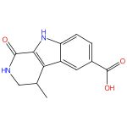 |  |  |  | 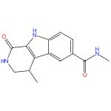

The discovery of carboline analogs as potent MAPKAP-K2 inhibitors
By: Wu, Jiang-Ping; et al
Bioorganic & Medicinal Chemistry Letters (2007), 17(16), 4664-4669.
Find It @ Emory
10.1016/j.bmcl.2007.05.101
View All Sources in CAS SciFinder

Steps: 1, Yield: 90%
CAS Reaction Number: 31-367-CAS-14370300
1.1 | Reagents: 1-Hydroxybenzotriazole, 1-Ethyl-3-(3′-dimethylaminopropyl)carbodiimide hydrochloride
 | Catalysts: 4-(Dimethylamino)pyridine
 | Solvents: Dimethylformamide; rt → 60 °C; overnight, 60 °C

28. Scheme 28 (1 Reaction)

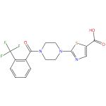 |  |  |  | 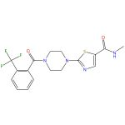

Thiazole analog as stearoyl-CoA desaturase 1 inhibitor
By: Li, Chun Sing; et al
Bioorganic & Medicinal Chemistry Letters (2009), 19(17), 5214-5217.
Find It @ Emory
10.1016/j.bmcl.2009.07.015
View All Sources in CAS SciFinder

Steps: 1, Yield: 90%
CAS Reaction Number: 31-367-CAS-5279686
1.1 | Reagents: Diisopropylethylamine, O-(7-Azabenzotriazol-1-yl)-N,N,N′,N′-tetramethyluronium hexafluorophosphate
 | Solvents: Dimethylformamide

29. Scheme 29 (1 Reaction)

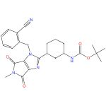 |  |  |  | 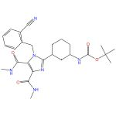

Xanthine mimetics as potent dipeptidyl peptidase IV inhibitors
By: Kurukulasuriya, Ravi; et al
Bioorganic & Medicinal Chemistry Letters (2006), 16(24), 6226-6230.
Find It @ Emory
10.1016/j.bmcl.2006.09.024
View All Sources in CAS SciFinder

Steps: 1, Yield: 90%
CAS Reaction Number: 31-363-CAS-11598649
1.1 | Solvents: Acetonitrile; 80 °C

30. Scheme 30 (1 Reaction)

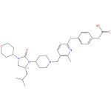  Absolute stereochemistry shown |  |  |  | 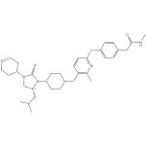  Absolute stereochemistry shown

Substituted imidazolidinones and related compounds as chemokine receptor binding compounds and their preparation, pharmaceutical compositions and use in the treatment of infection of target cells by human immunodeficiency virus
Assignee: AnorMED Inc.
World Intellectual Property Organization, WO2007022371 A2 2007-02-22
Espacenet
View All Sources in CAS SciFinder

Steps: 1, Yield: 90%
CAS Reaction Number: 31-367-CAS-11810481
1.1 | Reagents: 1-Hydroxybenzotriazole, Diisopropylethylamine, 1-Ethyl-3-(3′-dimethylaminopropyl)carbodiimide hydrochloride
 | Solvents: Dichloromethane; 1 - 3 d, rt

31. Scheme 31 (1 Reaction)

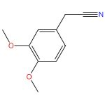 |  |  |  | 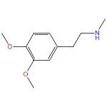

Nickel-catalyzed hydrogenative coupling of nitriles and amines for general amine synthesis
By: Chandrashekhar, Vishwas G.; et al
Science (Washington, DC, United States) (2022), 376(6600), 1433-1441.
Find It @ Emory
10.1126/science.abn7565
View All Sources in CAS SciFinder

Steps: 1, Yield: 90%
CAS Reaction Number: 31-614-CAS-32794909
1.1 | Reagents: Hydrogen
 | Catalysts: 1,1′-[2-[(Diphenylphosphino)methyl]-2-methyl-1,3-propanediyl]bis[1,1-diphenylphosphine], Methanesulfonic acid, 1,1,1-trifluoro-, nickel(2+) salt (2:1)
 | Solvents: 2,2,2-Trifluoroethanol; 16 h, 40 bar, 100 °C

32. Scheme 32 (1 Reaction)

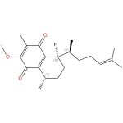  Absolute stereochemistry shown,  Rotation (+) |  |  |  | 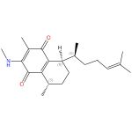  Absolute stereochemistry shown

Synthetic and Isolation Studies Related to the Marine Natural Products (+)-Elisabethadione and (+)-Elisabethamine
By: Dai, Xing; et al
Journal of Organic Chemistry (2007), 72(6), 1895-1900.
Find It @ Emory
10.1021/jo0618167
View All Sources in CAS SciFinder

Steps: 1, Yield: 90%
CAS Reaction Number: 31-260-CAS-1771762
1.1 | Solvents: Ethanol, Tetrahydrofuran; 23 °C; 20 h, rt

33. Scheme 33 (3 Reactions)

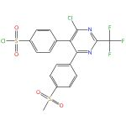 |  |  |  | 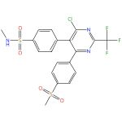

Preparation of novel heterocycles as PDE4 inhibitors
Assignee: Orchid Research Laboratories Limited
World Intellectual Property Organization, WO2009095773 A2 2009-08-06
Espacenet
View All Sources in CAS SciFinder

Steps: 1, Yield: 90%
CAS Reaction Number: 31-393-CAS-8265584
1.1 | Solvents: Dichloromethane, Water; 15 min, 0 - 10 °C

Preparation of pyrimidine derivatives as inhibitors of cytokines for the treatment of immunological and other diseases
Assignee: Orchid Research Laboratories Limited.
United States, US20080207606 A1 2008-08-28
Espacenet
View All Sources in CAS SciFinder

Steps: 1, Yield: 90%
CAS Reaction Number: 31-393-CAS-8604062
1.1 | Solvents: Dichloromethane, Water; 15 min, 0 - 10 °C

Preparation of pyrimidine derivatives as inhibitors of cytokines for the treatment of immunological and other diseases
Assignee: Orchid Research Laboratories Limited.
United States, US20070167413 A1 2007-07-19
Espacenet
View All Sources in CAS SciFinder

Steps: 1, Yield: 90%
CAS Reaction Number: 31-393-CAS-6978989
1.1 | Solvents: Dichloromethane, Water; 15 min, 0 - 10 °C

34. Scheme 34 (1 Reaction)

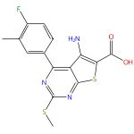 |  |  |  | 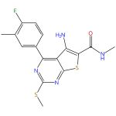

Preparation of thieno[2,3-d]pyrimidines as inhibitors of TNFα, PDE4 and B-raf, their compositions and use
Assignee: Signal Pharmaceuticals, LLC
World Intellectual Property Organization, WO2007084560 A2 2007-07-26
Espacenet
View All Sources in CAS SciFinder

Steps: 1, Yield: 90%
CAS Reaction Number: 31-367-CAS-1190712
1.1 | Reagents: 1-Ethyl-3-(3′-dimethylaminopropyl)carbodiimide, 1-Hydroxybenzotriazole
 | Solvents: Tetrahydrofuran

35. Scheme 35 (1 Reaction)

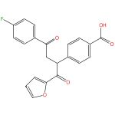 |  |  |  | 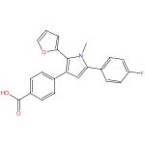

Scope and applicability of an expedient synthesis leading to polysubstituted 3-(carboxyphenyl)pyrroles
By: Ullrich, Thomas; et al
Synthetic Communications (2007), 37(7), 1109-1119.
Find It @ Emory
10.1080/00397910701198898
View All Sources in CAS SciFinder

Steps: 1, Yield: 90%
CAS Reaction Number: 31-309-CAS-11889854
1.1 | Solvents: Ethanol; 3 h, reflux

36. Scheme 36 (1 Reaction)

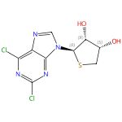  Absolute stereochemistry shown,  Rotation (-) |  |  |  | 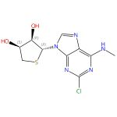  Absolute stereochemistry shown

Preparation of adenosine nucleoside analogs for the prevention and treatment of the inflammatory diseases
Assignee: FM Therapeutics Co., Ltd.
World Intellectual Property Organization, WO2008108508 A1 2008-09-12
Espacenet
View All Sources in CAS SciFinder

Steps: 1, Yield: 90%
CAS Reaction Number: 31-172-CAS-12803027
1.1 | Solvents: Ethanol; 2 - 3 h, rt

37. Scheme 37 (1 Reaction)

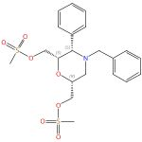  Absolute stereochemistry shown,  Rotation (-) |  |  |  | 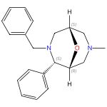  Absolute stereochemistry shown,  Rotation (+)

Enantioselective synthesis of 2-phenyl-9-oxabispidines
By: Breuning, Matthias; et al
Synthesis (2007), (11), 1702-1706.
Find It @ Emory
10.1055/s-2007-966040
View All Sources in CAS SciFinder

Steps: 1, Yield: 90%
CAS Reaction Number: 31-031-CAS-11995750
1.1 | Solvents: Water; 36 h, 50 °C

38. Scheme 38 (1 Reaction)

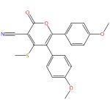 |  |  |  | 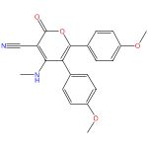

Highly convenient regioselective synthesis of functionalized arylated benzene from ketene-S,S-acetal under mild conditions at room temperature
By: Kumar, Vijay; et al
Tetrahedron Letters (2009), 50(6), 680-683.
Find It @ Emory
10.1016/j.tetlet.2008.11.098
View All Sources in CAS SciFinder

Steps: 1, Yield: 90%
CAS Reaction Number: 31-260-CAS-9993887
1.1 | Solvents: Methanol; 1 - 2 h, reflux

39. Scheme 39 (1 Reaction)

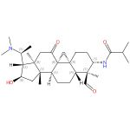  Absolute stereochemistry shown |  |  |  | 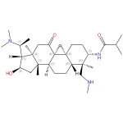  Absolute stereochemistry shown

New potent human acetylcholinesterase inhibitors in the tetracyclic triterpene series with inhibitory potency on amyloid β aggregation
By: Rouleau, Julien; et al
European Journal of Medicinal Chemistry (2011), 46(6), 2193-2205.
Find It @ Emory
10.1016/j.ejmech.2011.02.073
View All Sources in CAS SciFinder

Steps: 1, Yield: 90%
CAS Reaction Number: 31-313-CAS-14389559
1.1 | Reagents: Sodium sulfate
 | Solvents: Ethanol; 12 h, 60 °C
1.2 | Reagents: Sodium cyanoborohydride
 | Solvents: Ethanol, Acetic acid; 0 °C; 1 h, rt

40. Scheme 40 (1 Reaction)

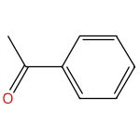 |  |  |  | 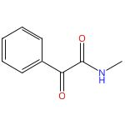

UV Assisted High-Efficient Synthesis of α-Ketoamides using Air Promoted by A Non-Metal Catalyst in Aqueous Solution
By: Li, Jianhui; et al
ChemCatChem (2018), 10(21), 4868-4873.
Find It @ Emory
10.1002/cctc.201801365
View All Sources in CAS SciFinder

Steps: 1, Yield: 90%
CAS Reaction Number: 31-614-CAS-30117876
1.1 | Reagents: Oxygen
 | Catalysts: N-Iodosuccinimide
 | Solvents: Water; 16 h, rt

41. Scheme 41 (1 Reaction)

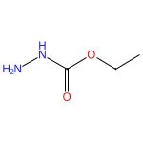 |  | 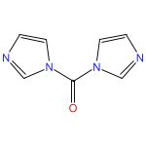
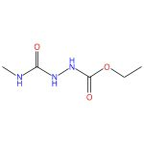 |  | 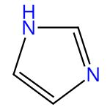

Development of a Scalable and Sublimation-Free Route to MTAD
By: Siddiqi, Zohaib R.; et al
Organic Process Research & Development (2020), 24(12), 2953-2959.
Find It @ Emory
10.1021/acs.oprd.0c00470
View All Sources in CAS SciFinder

Steps: 1, Yield: 100%
CAS Reaction Number: 31-614-CAS-26587942
1.1 | Solvents: Tetrahydrofuran; 15 min, 0 °C; 2 h, 0 °C
1.2 | Reagents: Hydrochloric acid
 | Solvents: Water; 0 °C; 0 °C → rt; 4 h, rt

42. Scheme 42 (1 Reaction)

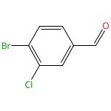 |  |  |  | 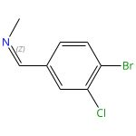  Double bond geometry shown
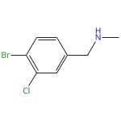

Preparation of 4-amino-7,8-dihydropyrimido[5,4-f][1,4]oxazepin-5(6)-one based DGAT1 inhibitors
Assignees: AstraZeneca AB; AstraZeneca UK Limited
World Intellectual Property Organization, WO2011121350 A1 2011-10-06
Espacenet
View All Sources in CAS SciFinder

Steps: 1, Yield: 99%
CAS Reaction Number: 31-309-CAS-1030226
1.1 | Reagents: Acetic acid, Sodium borohydride
 | Solvents: Tetrahydrofuran; 20 °C; 4 h, rt
1.2 | Reagents: Sodium bicarbonate
 | Solvents: Water; rt

43. Scheme 43 (1 Reaction)

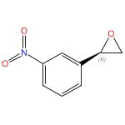  Absolute stereochemistry shown,  Rotation (-) |  |  |  | 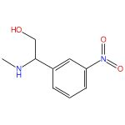
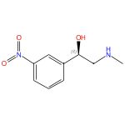
Absolute stereochemistry shown

Whole-cell yeast-mediated preparation of (R)-2-chloro-1-(3-nitrophenyl)ethanol as a synthetic precursor for (R)-phenylephrine
By: Tokoshima, Daisuke; et al
Journal of Molecular Catalysis B: Enzymatic (2013), 97, 95-99.
Find It @ Emory
10.1016/j.molcatb.2013.07.021
View All Sources in CAS SciFinder

Steps: 1, Yield: 98%
CAS Reaction Number: 31-035-CAS-5995010
1.1 | Solvents: Methanol, Water; 1 h, 50 °C

44. Scheme 44 (1 Reaction)

 |  | 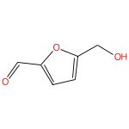 |  | 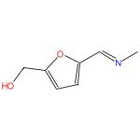
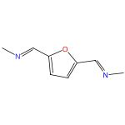

An efficient approach to synthesizing 2,5-bis(N-methyl-aminomethyl)furan from 5-hydroxymethylfurfural via 2,5-bis(N-methyl-iminomethyl)furan using a two-step reaction in one pot
By: Zhang, Jie; et al
Green Chemistry (2021), 23(15), 5656-5664.
Find It @ Emory
10.1039/d1gc01635k
View All Sources in CAS SciFinder

Steps: 1, Yield: 98%
CAS Reaction Number: 31-614-CAS-24485215
1.1 | Catalysts: Manganese oxide (MnO₂)
 | Solvents: Methanol; 3 h, 1 MPa, 90 °C

45. Scheme 45 (1 Reaction)

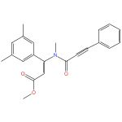 |  |  |  | 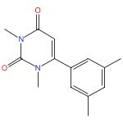
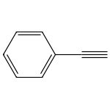

A Regioselective Synthesis of 6-Alkyl- and 6-Aryluracils by Cs2CO3- or K3PO4-Promoted Dimerization of 3-Alkyl- and 3-Aryl-2-Propynamides
By: Rajapaksha, Suranga M.; et al
Journal of Organic Chemistry (2017), 82(11), 5678-5688.
Find It @ Emory
10.1021/acs.joc.7b00508
View All Sources in CAS SciFinder

Steps: 1, Yield: 96%
CAS Reaction Number: 31-368-CAS-17222949
1.1 | Solvents: Toluene, Water; 24 h, rt

46. Scheme 46 (1 Reaction)

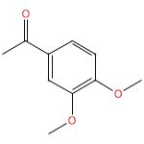 |  |  |  | 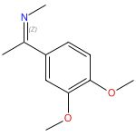  Double bond geometry shown
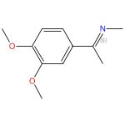

Double bond geometry shown

Disulfonimide-Catalyzed Asymmetric Reduction of N-Alkyl Imines
By: Wakchaure, Vijay N.; et al
Angewandte Chemie, International Edition (2015), 54(40), 11852-11856.
Find It @ Emory
10.1002/anie.201504052
View All Sources in CAS SciFinder

Steps: 1, Yield: 95%
CAS Reaction Number: 31-309-CAS-1862524
1.1 | Solvents: Ethanol; 0 °C; 3 d, rt

47. Scheme 47 (1 Reaction)

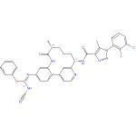  Absolute stereochemistry shown  Double bond geometry shown |  |  |  | 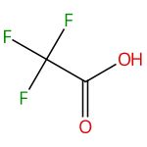
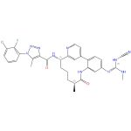  Absolute stereochemistry shown  Double bond geometry shown |  | 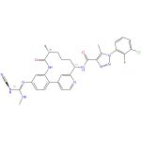  Absolute stereochemistry shown  Double bond geometry shown

Novel macrocycles as factor XIa inhibitors and their preparation
Assignee: Bristol-Myers Squibb Company
World Intellectual Property Organization, WO2013022818 A1 2013-02-14
Espacenet
View All Sources in CAS SciFinder

Steps: 1, Yield: 95%
CAS Reaction Number: 31-368-CAS-14593568
1.1 | Solvents: Isopropanol; 2 h, rt
1.2 | -

48. Scheme 48 (1 Reaction)

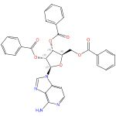  Absolute stereochemistry shown |  |  |  | 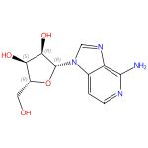  Absolute stereochemistry shown
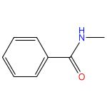

Facile synthesis of a 3-deazaadenosine phosphoramidite for RNA solid-phase synthesis
By: Mairhofer, Elisabeth; et al
Beilstein Journal of Organic Chemistry (2016), 12, 2556-2562.
Find It @ Emory
10.3762/bjoc.12.250
View All Sources in CAS SciFinder

Steps: 1, Yield: 95%
CAS Reaction Number: 31-352-CAS-19662048
1.1 | Solvents: Ethanol, Water; 18 h, rt

49. Scheme 49 (1 Reaction)

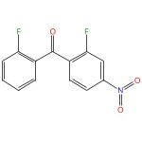 |  |  |  | 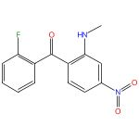
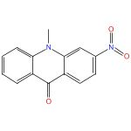

Synthesis of heterocyclic compounds via nucleophilic aroylation catalyzed by imidazolidenyl carbene
By: Suzuki, Yumiko; et al
Chemical & Pharmaceutical Bulletin (2006), 54(12), 1653-1658.
Find It @ Emory
10.1248/cpb.54.1653
View All Sources in CAS SciFinder

Steps: 1, Yield: 95%
CAS Reaction Number: 31-172-CAS-383959
1.1 | Solvents: 1,4-Dioxane; 6 h, reflux

50. Scheme 50 (1 Reaction)

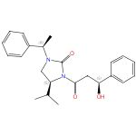  Absolute stereochemistry shown,  Rotation (+) |  |  |  | 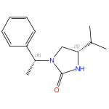  Absolute stereochemistry shown,  Rotation (+)
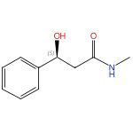
Absolute stereochemistry shown,

Rotation (-)

Reversal of selectivity in acetate aldol reactions of N-acetyl-(S)-4-isopropyl-1-[(R)-1-phenylethyl]imidazolidin-2-one
By: Khatik, Gopal L.; et al
Organic Letters (2012), 14(10), 2442-2445.
Find It @ Emory
10.1021/ol300949s
View All Sources in CAS SciFinder

Steps: 1, Yield: 94%
CAS Reaction Number: 31-363-CAS-14272286
1.1 | Solvents: Methanol, Water; 5 h, reflux

51. Scheme 51 (1 Reaction)

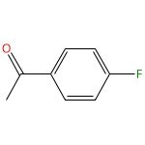 |  |  |  | 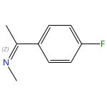  Double bond geometry shown
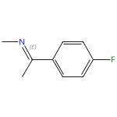

Double bond geometry shown

Disulfonimide-Catalyzed Asymmetric Reduction of N-Alkyl Imines
By: Wakchaure, Vijay N.; et al
Angewandte Chemie, International Edition (2015), 54(40), 11852-11856.
Find It @ Emory
10.1002/anie.201504052
View All Sources in CAS SciFinder

Steps: 1, Yield: 94%
CAS Reaction Number: 31-309-CAS-6450631
1.1 | Solvents: Ethanol; 0 °C; 3 d, rt

52. Scheme 52 (1 Reaction)

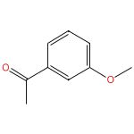 |  |  |  | 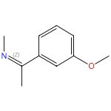  Double bond geometry shown
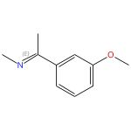

Double bond geometry shown

Disulfonimide-Catalyzed Asymmetric Reduction of N-Alkyl Imines
By: Wakchaure, Vijay N.; et al
Angewandte Chemie, International Edition (2015), 54(40), 11852-11856.
Find It @ Emory
10.1002/anie.201504052
View All Sources in CAS SciFinder

Steps: 1, Yield: 94%
CAS Reaction Number: 31-309-CAS-3727911
1.1 | Solvents: Ethanol; 0 °C; 3 d, rt

53. Scheme 53 (1 Reaction)

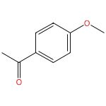 |  |  |  | 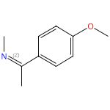  Double bond geometry shown
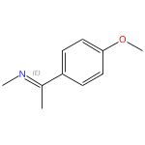

Double bond geometry shown

Disulfonimide-Catalyzed Asymmetric Reduction of N-Alkyl Imines
By: Wakchaure, Vijay N.; et al
Angewandte Chemie, International Edition (2015), 54(40), 11852-11856.
Find It @ Emory
10.1002/anie.201504052
View All Sources in CAS SciFinder

Steps: 1, Yield: 93%
CAS Reaction Number: 31-309-CAS-4307742
1.1 | Solvents: Ethanol; 0 °C; 3 d, rt

54. Scheme 54 (1 Reaction)

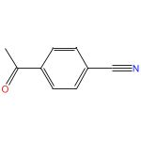 |  |  |  | 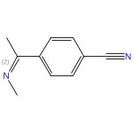  Double bond geometry shown
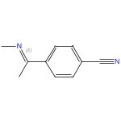

Double bond geometry shown

Disulfonimide-Catalyzed Asymmetric Reduction of N-Alkyl Imines
By: Wakchaure, Vijay N.; et al
Angewandte Chemie, International Edition (2015), 54(40), 11852-11856.
Find It @ Emory
10.1002/anie.201504052
View All Sources in CAS SciFinder

Steps: 1, Yield: 93%
CAS Reaction Number: 31-309-CAS-14970064
1.1 | Solvents: Ethanol; 0 °C; 3 d, rt

55. Scheme 55 (1 Reaction)

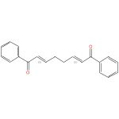  Double bond geometry shown |  |  |  | 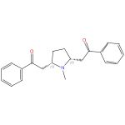  Relative stereochemistry shown
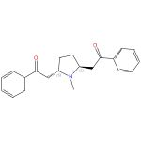
Relative stereochemistry shown

Thermodynamic epimeric equilibration and crystallisation-induced dynamic resolution of lobelanine, norlobelanine and related analogues
By: Amara, Z.; et al
Organic & Biomolecular Chemistry (2014), 12(48), 9797-9810.
Find It @ Emory
10.1039/c4ob01787k
View All Sources in CAS SciFinder

Steps: 1, Yield: 93%
CAS Reaction Number: 31-260-CAS-3772345
1.1 | Solvents: Tetrahydrofuran; 15 min, rt

56. Scheme 56 (1 Reaction)

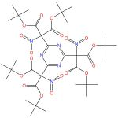 |  | 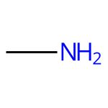 |  | 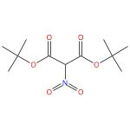
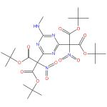

Trisubstituted 1,3,5-triazines. 5. Reaction of 2,4,6-tris[di(tert-butoxycarbonyl)nitromethyl]-1,3,5-triazine with nucleophiles
By: Shastin, A. V.; et al
Chemistry of Heterocyclic Compounds (New York, NY, United States)(Translation of Khimiya Geterotsiklicheskikh Soedinenii) (2003), 39(5), 624-631.
Find It @ Emory
View All Sources in CAS SciFinder

Steps: 1, Yield: 93%
CAS Reaction Number: 31-614-CAS-28548914
1.1 | Solvents: Diethyl ether, Water; rt

57. Scheme 57 (1 Reaction)

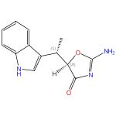  Relative stereochemistry shown |  |  |  | 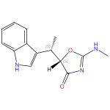  Relative stereochemistry shown
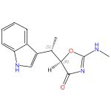
Relative stereochemistry shown

Development of a stereoselective practical synthetic route to indolmycin, a candidate anti-H. pylori agent
By: Hasuoka, Atsushi; et al
Chemical & Pharmaceutical Bulletin (2001), 49(12), 1604-1608.
Find It @ Emory
10.1248/cpb.49.1604
View All Sources in CAS SciFinder

Steps: 1, Yield: 93%
CAS Reaction Number: 31-033-CAS-4025002
1.1 | Solvents: Water

58. Scheme 58 (1 Reaction)

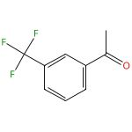 |  |  |  | 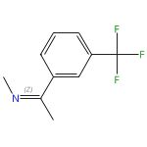  Double bond geometry shown
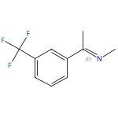

Double bond geometry shown

Disulfonimide-Catalyzed Asymmetric Reduction of N-Alkyl Imines
By: Wakchaure, Vijay N.; et al
Angewandte Chemie, International Edition (2015), 54(40), 11852-11856.
Find It @ Emory
10.1002/anie.201504052
View All Sources in CAS SciFinder

Steps: 1, Yield: 93%
CAS Reaction Number: 31-309-CAS-5842240
1.1 | Solvents: Ethanol; 0 °C; 3 d, rt

59. Scheme 59 (1 Reaction)

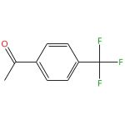 |  |  |  | 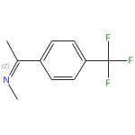  Double bond geometry shown
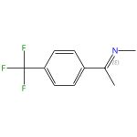

Double bond geometry shown

Disulfonimide-Catalyzed Asymmetric Reduction of N-Alkyl Imines
By: Wakchaure, Vijay N.; et al
Angewandte Chemie, International Edition (2015), 54(40), 11852-11856.
Find It @ Emory
10.1002/anie.201504052
View All Sources in CAS SciFinder

Steps: 1, Yield: 93%
CAS Reaction Number: 31-309-CAS-12841000
1.1 | Solvents: Ethanol; 0 °C; 3 d, rt

60. Scheme 60 (1 Reaction)

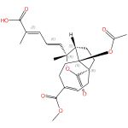  Absolute stereochemistry shown,  Rotation (-)  Double bond geometry shown |  |  |  | 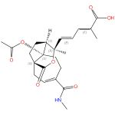  Absolute stereochemistry shown  Double bond geometry shown
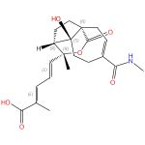
Absolute stereochemistry shown

Double bond geometry shown

Antifungal diterpenoids of Pseudolarix kaempferi, and their structure-activity relationship study
By: Yang, Sheng-Ping; et al
Bioorganic & Medicinal Chemistry (2003), 11(21), 4577-4584.
Find It @ Emory
10.1016/s0968-0896(03)00531-5
View All Sources in CAS SciFinder

Steps: 1, Yield: 93%
CAS Reaction Number: 31-352-CAS-7838239
1.1 | Reagents: Acetic acid
 | Solvents: Water; 6 h, pH 6, rt

61. Scheme 61 (1 Reaction)

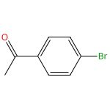 |  |  |  | 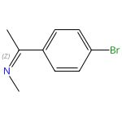  Double bond geometry shown
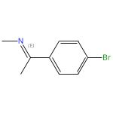

Double bond geometry shown

Disulfonimide-Catalyzed Asymmetric Reduction of N-Alkyl Imines
By: Wakchaure, Vijay N.; et al
Angewandte Chemie, International Edition (2015), 54(40), 11852-11856.
Find It @ Emory
10.1002/anie.201504052
View All Sources in CAS SciFinder

Steps: 1, Yield: 93%
CAS Reaction Number: 31-309-CAS-10709881
1.1 | Solvents: Ethanol; 0 °C; 3 d, rt

62. Scheme 62 (1 Reaction)

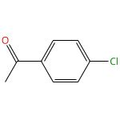 |  |  |  | 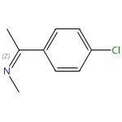  Double bond geometry shown
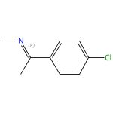

Double bond geometry shown

Disulfonimide-Catalyzed Asymmetric Reduction of N-Alkyl Imines
By: Wakchaure, Vijay N.; et al
Angewandte Chemie, International Edition (2015), 54(40), 11852-11856.
Find It @ Emory
10.1002/anie.201504052
View All Sources in CAS SciFinder

Steps: 1, Yield: 93%
CAS Reaction Number: 31-309-CAS-8580418
1.1 | Solvents: Ethanol; 0 °C; 3 d, rt

63. Scheme 63 (1 Reaction)

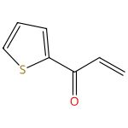 |  |  |  | 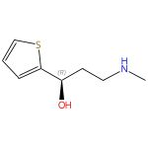  Absolute stereochemistry shown,  Rotation (+)
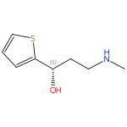
Absolute stereochemistry shown,

Rotation (-)

A Michael Addition-Asymmetric Transfer Hydrogenation One-Pot Enantioselective Tandem Process for Syntheses of Chiral γ-Secondary Amino Alcohols
By: Wu, Liang; et al
Organic Letters (2017), 19(12), 3047-3050.
Find It @ Emory
10.1021/acs.orglett.7b00823
View All Sources in CAS SciFinder

Steps: 1, Yield: 92%
CAS Reaction Number: 31-513-CAS-17241074
1.1 | Reagents: Sodium carbonate
 | Solvents: Isopropanol, Water; 2 h, rt
1.2 | Reagents: Sodium formate, Chlorine hydride (ClH₂)
 | Catalysts: [N-[(1S,2S)-2-(Amino-κN)-1,2-diphenylethyl]-4-methylbenzenesulfonamidato-κN]chloro[(1,2,3,4,5,6-η)-1,3,5-trimethylbenzene]ruthenium
 | Solvents: Water; 8 h, pH 7, 40 °C

64. Scheme 64 (1 Reaction)

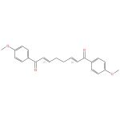  Double bond geometry shown |  |  |  | 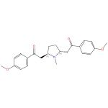  Relative stereochemistry shown
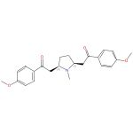
Relative stereochemistry shown

Thermodynamic epimeric equilibration and crystallisation-induced dynamic resolution of lobelanine, norlobelanine and related analogues
By: Amara, Z.; et al
Organic & Biomolecular Chemistry (2014), 12(48), 9797-9810.
Find It @ Emory
10.1039/c4ob01787k
View All Sources in CAS SciFinder

Steps: 1, Yield: 92%
CAS Reaction Number: 31-260-CAS-14750906
1.1 | Solvents: Dichloromethane, Tetrahydrofuran; rt

65. Scheme 65 (1 Reaction)

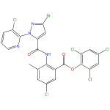 |  |  |  | 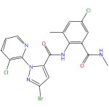
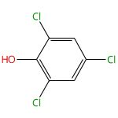

A novel process for preparation of chlorantraniliprole and intermediates thereof
Assignee: Seedlings India Private Limited
India, IN202111031718 A 2023-03-03
Espacenet
View All Sources in CAS SciFinder

Steps: 1, Yield: 92%
CAS Reaction Number: 31-614-CAS-40141623
1.1 | Reagents: Sodium bicarbonate
 | Solvents: Acetonitrile; 8 h, 30 - 40 °C
1.2 | Reagents: Hydrochloric acid
 | Solvents: Water; neutralized

66. Scheme 66 (1 Reaction)

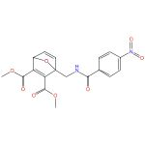 |  |  |  | 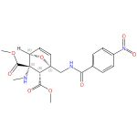  Relative stereochemistry shown
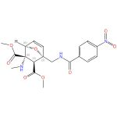
Relative stereochemistry shown

Degradable Conjugates from Oxanorbornadiene Reagents
By: Kislukhin, Alexander A.; et al
Journal of the American Chemical Society (2012), 134(14), 6491-6497.
Find It @ Emory
10.1021/ja301491h
View All Sources in CAS SciFinder

Steps: 1, Yield: 91%
CAS Reaction Number: 31-260-CAS-6765704
1.1 | Solvents: Acetonitrile-d₃, Water; 1 min, 23 °C

67. Scheme 67 (1 Reaction)

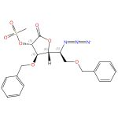  Absolute stereochemistry shown,  Rotation (-) |  |  |  | 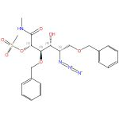  Absolute stereochemistry shown
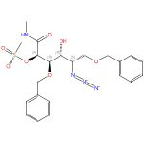
Absolute stereochemistry shown

Nine of 16 Stereoisomeric Polyhydroxylated Proline Amides Are Potent β-N-Acetylhexosaminidase Inhibitors
By: Ayers, Benjamin J.; et al
Journal of Organic Chemistry (2014), 79(8), 3398-3409.
Find It @ Emory
10.1021/jo500157p
View All Sources in CAS SciFinder

Steps: 1, Yield: 91%
CAS Reaction Number: 31-368-CAS-20725
1.1 | Solvents: Ethanol, 1,4-Dioxane; 16 h, rt

68. Scheme 68 (1 Reaction)

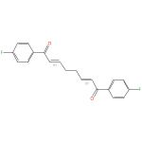  Double bond geometry shown |  |  |  | 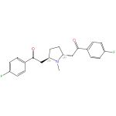  Relative stereochemistry shown
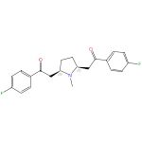
Relative stereochemistry shown

Thermodynamic epimeric equilibration and crystallisation-induced dynamic resolution of lobelanine, norlobelanine and related analogues
By: Amara, Z.; et al
Organic & Biomolecular Chemistry (2014), 12(48), 9797-9810.
Find It @ Emory
10.1039/c4ob01787k
View All Sources in CAS SciFinder

Steps: 1, Yield: 91%
CAS Reaction Number: 31-260-CAS-11109157
1.1 | Solvents: Dichloromethane, Tetrahydrofuran; 15 min, rt

69. Scheme 69 (1 Reaction)

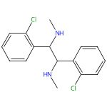

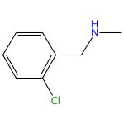

Reductive imino-pinacol coupling reaction of halogenated aromatic imines and iminium ions catalyzed by precious metal catalysts using hydrogen
By: Dumoleijn, K. N. R.; et al
Journal of Catalysis (2021), 400, 103-113.
Find It @ Emory
10.1016/j.jcat.2021.05.023
View All Sources in CAS SciFinder

Steps: 1, Yield: 91%
CAS Reaction Number: 31-614-CAS-24618582
1.1 | Solvents: Methanol; 60 min, 80 °C; cooled
1.2 | Reagents: Hydrogen; 20 h, 1.2 MPa, 343 K

70. Scheme 70 (1 Reaction)

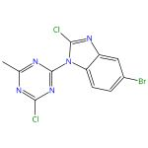 |  | 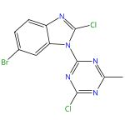
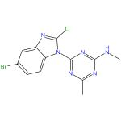 |  | 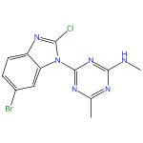

Preparation of indole and benzimidazole compounds as mTOR kinase inhibitors for the treatment of cancer
Assignee: Amgen Inc.
World Intellectual Property Organization, WO2010096314 A1 2010-08-26
Espacenet
View All Sources in CAS SciFinder

Steps: 1, Yield: 90%
CAS Reaction Number: 31-172-CAS-650021
1.1 | Solvents: Tetrahydrofuran, 1,4-Dioxane; overnight, rt

71. Scheme 71 (1 Reaction)

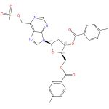  Absolute stereochemistry shown |  |  |  | 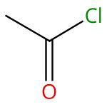
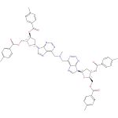  Absolute stereochemistry shown |  | 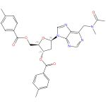  Absolute stereochemistry shown

Synthesis, cytostatic, and anti-HCV activity of 6-(N-substituted aminomethyl)-, 6-(O-substituted hydroxymethyl)- and 6-(S-substituted sulfanylmethyl)purine nucleosides
By: Silhar, Peter; et al
Bioorganic & Medicinal Chemistry (2008), 16(5), 2329-2366.
Find It @ Emory
10.1016/j.bmc.2007.11.067
View All Sources in CAS SciFinder

Steps: 1, Yield: 90%
CAS Reaction Number: 31-031-CAS-15203542
1.1 | Solvents: Acetonitrile; 2 h, rt
1.2 | Reagents: Triethylamine
 | Solvents: Dichloromethane; 8 h, rt
1.3 | Reagents: Monosodium phosphate
 | Solvents: Water; rt

72. Scheme 72 (1 Reaction)

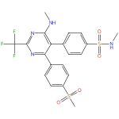

Preparation of novel heterocycles as PDE4 inhibitors
Assignee: Orchid Research Laboratories Ltd.
India, IN261399 B 2014-06-27
Espacenet
View All Sources in CAS SciFinder

Steps: 1, Yield: 90%
CAS Reaction Number: 31-172-CAS-19203834
1.1 | Solvents: Dichloromethane, Water; 15 min, 0 - 10 °C

73. Scheme 73 (1 Reaction)

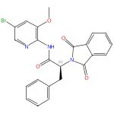  Absolute stereochemistry shown |  |  |  | 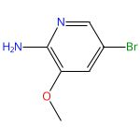
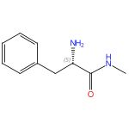  Absolute stereochemistry shown,  Rotation (+) |  | 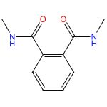

Ortho-substituent effect promoted rapid cleavage of amide C-N bond under mild conditions
By: Wang, Peng; et al
Research on Chemical Intermediates (2014), 40(8), 2935-2943.
Find It @ Emory
10.1007/s11164-013-1140-1
View All Sources in CAS SciFinder

Steps: 1, Yield: 90%
CAS Reaction Number: 31-363-CAS-545429
1.1 | Solvents: Ethanol; 20 min, rt

74. Scheme 74 (1 Reaction)

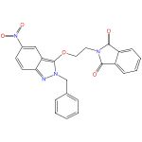 |  |  |  | 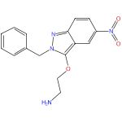
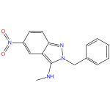 |  | 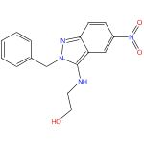

Antichagasic, Leishmanicidal, and Trichomonacidal Activity of 2-Benzyl-5-nitroindazole-Derived Amines
By: Fonseca-Berzal, Cristina; et al
ChemMedChem (2018), 13(12), 1246-1259.
Find It @ Emory
10.1002/cmdc.201800084
View All Sources in CAS SciFinder

Steps: 1, Yield: 90%
CAS Reaction Number: 31-172-CAS-19285553
1.1 | Solvents: Water; 4 h, 80 °C

Copyright © 2025 American Chemical Society (ACS). All Rights Reserved.

